
Spring Interim Report

Theses: Docker Containers Deployed Using Bluemix

Name: Thomas Flynn

ID: 16117743

Supervisor: Dr. Sean McGrath

Course: Information & Network Security MEng

Year: 2017

Department: Electronic & Computer Engineering

Table of Contents
1 Introduction and Report Outline 8
1.1 Project Description 8
1.2 Report Outline 9
2 Literature Survey 10
2.1 Section Outline 10
2.2 IoT Architecture 11
2.3 Load Balancing 12
2.4 MQTT Brokers and Clients 13
2.5 Redis 14
2.6 Kafka 14
2.7 ELK Stack 15
2.8 IBM Bluemix Logging and Monitoring 16
2.9 Container Orchestration 17
2.10 Service Discovery 18
2.11 Amalgam8 19
2.12 DevOps CI/CD Pipeline 20
2.13 InfluxDB 21
2.14 REST and MQTT 22
2.15 Similar Projects 24
3 Architecture 25
3.1 Autumn High Level Design Diagram 25
3.2 Overall Architecture 26
3.3 Use-case: Schuman Building 27
3.4 Load Balancing Architecture 28
4 Theory 29
4.1 Mosca Node.js Code 29
4.2 Bluemix Container Service 31
4.3 Mosca Broker Container 32
4.4 Mosca Broker Container Group 33
4.5 HaProxy Container Configuration 34
4.6 Node-Red 36
4.7 OpenWhisk 37
4.8 Continuous Deployment Pipeline 38
5 Project Management 40
5.1 Strategy 40
5.2 Trello Project Labels 40
5.3 Project Iteration Planning 41
5.4 Iteration 1: June 5th – June 25th 42
5.5 Iteration 2: June 26th – July 16th 42
5.6 Iteration 3: July 17th – August 6th 42
5.7 Iteration 4: August 7th – August 27th 42
6 Progress to Date 43
6.1 Christmas Break Summary 43
6.2 Week 1 Log 44
6.3 Week 2 Log 46
6.4 Week 3 Log 48
6.5 Week 4 Log 50
7 Evaluation 52
7.1 Database Comparison 52
7.2 Container Memory Limitations 53
7.3 Considerations 53
8 Bibliography 54
Illustration Index
Illustration 1: IoT pub/sub data 11
Illustration 2: IoT pub/sub commands 11
Illustration 3: HAProxy Logo 12
Illustration 4: HAProxy Broker Diagram 12
Illustration 5: HAProxy SSL Decryption 12
Illustration 6: Mosca Logo 13
Illustration 7: RabbitMQ Logo 13
Illustration 8: MQTT.js Logo 13
Illustration 9: Redis Logo 14
Illustration 10: Kafka Logo 14
Illustration 11: Kafka Architecture 14
Illustration 12: Elastisearch Logo 15
Illustration 13: Logstash Logo 15
Illustration 14: Kibana Logo 15
Illustration 15: ELK Stack Diagram 15
Illustration 16: IBM Containers Logo 16
Illustration 17: Bluemix Container Service Logging 16
Illustration 18: Container Orchestration Legend 17
Illustration 19: Container Orchestration 17
Illustration 20: Service Discovery 18
Illustration 21: Amalgam8 Logo 19
Illustration 22: Amalgam8 Architecture 19
Illustration 23: IBM Bluemix DevOps Services Logo 20
Illustration 24: Continuous Integration 20
Illustration 25: InfluxDB Logo 21
Illustration 26: REST and MQTT Mirroring 22
Illustration 27: REST and MQTT Interface 23
Illustration 28: TRANSIT Diagram 24
Illustration 29: Autumn High Level Design 25
Illustration 30: Overall Architecture 26
Illustration 31: Use Case Schuman Building 27
Illustration 32: Loadbalancing Architecture 28
Illustration 33: Mosca Logo 29
Illustration 34: Mosca Redis COnfiguration 29
Illustration 35: Redis Persistence 29
Illustration 36: Mosca Authenticate 30
Illustration 37: Mosca Authorize Publish 30
Illustration 38: Mosca Authorize Subscribe 30
Illustration 39: Bluemix Logo 31
Illustration 40: Container Service Login 31
Illustration 41: Setting Namespace 31
Illustration 42: Bluemix Dashboard 31
Illustration 43: Cloning Mosca Repository 31
Illustration 44: Pushing Mosca Image 31
Illustration 45: Mosca Broker Test 32
Illustration 46: Container Group 33
Illustration 47: HAProxy Config 34
Illustration 48: HAProxy Dockerfile 34
Illustration 49: Primary Flow 36
Illustration 50: Test Cloudant Flow 36
Illustration 51: OpenWhisk Decode Action 37
Illustration 52: Http Request Node 37
Illustration 53: Deploy Fails 38
Illustration 54: Package Vulnerability 38
Illustration 55: Vulnerability Advisor Dashboard 38
Illustration 56: Edit Run Conditions 39
Illustration 57: Validation Stage Running 39
Illustration 58: Continue to Deploy 39
Illustration 59: Successful Deployment 39
Illustration 60: Project Labels 40
Illustration 61: Trello Iteration Planning 41
Illustration 62: Week 1 Bar Chart 44
Illustration 63: Week 1 Time Log 2 45
Illustration 64: Week 1 Time Log 1 45
Illustration 65: Week 2 Bar Chart 46
Illustration 66: Week 2 Time Log 2 47
Illustration 67: Week 2 Time Log 1 47
Illustration 68: Week 3 Bar Chart 48
Illustration 69: Week 3 Time Log 48
Illustration 70: Week 4 Bar Chart 50
Illustration 71: Week 4 Time Log 50
Illustration 72: db-engines 1 52
Illustration 73: db-engines 2 52

1 Introduction and Report Outline

1.1 Project Description
Docker Containers remove unnecessary resources out of the operating system. This increases CPU, memory, and network resources for middleware and application execution. As a general rule of thumb, Containers are 10 times more efficient than virtual machines in terms of CPU, memory, network and other resource utilization.
IBM has formed a close partnership with Docker in order to make Containers Enterprise Ready. IBM Software products such as Websphere Application Server (WAS) and IBM BlueMix are already Container ready.
This project is based on open source standards and is aimed at engineering a scalable back-end solution for tracking in real-time the number of vehicles and students on the university campus. Due to their scalable capabilities, Containers were chosen in order to handle the variation of traffic on campus over a 24 hour period. During periods of peak traffic, the number of Containers handling the processing of sensor data can efficiently scale up to meet demand. Computing resources will not be wasted during periods of low traffic because the number of Containers will be automatically scaled down.
The clients (cars, students) will transmit GPS (Global Position System) data periodically to the server using a lightweight IoT protocol known as MQTT (MQ Telemetry Transport). This is a commonly used protocol for constrained devices. Both client and server will incorporate features to ensure that communication and caching of data is only performed when appropriate. For example the client will not attempt to transmit data if its coordinates are outside college bounds, similarly the server won’t cache data received that is outside college bounds.
IBM Cloudant is a managed NoSQL JSON database service built to ensure that the flow of data between an application and its database remains uninterrupted and highly performant. Cloudant has excellent features for indexing, quering and visualizing geo-spatial data.
InfluxDB is used to organize the data from the sensors into a time-series for efficiency. OpenWhisk actions will be triggered to organize the data geo-spatially from Cloudant before feeding it into the time-series database.
Node-RED is a simple visual tool that makes it easy to wire together events and devices for the Internet of Things. To test the scalability of the application, Node-Red flows will inject messages to the MQTT topics “car-iotp” and “mobile-iotp” in order to determine the load balancing benchmarks of the project.
In order to help future students build applications on top of this project, various Development Operations aspects will be considered such as GitHub repositories, continuous integration/deployment pipelines, Container orchestration and microservices frameworks such as Amalgam8. This area of the project aims to reduce the operational complexity for future students who want to develop scalable Smart Campus Applications using microservices.

1.2 Report Outline

1.2.1 Overall Outline

2 Literature Survey

2.1 Kubernetes

2.1.1 About Kubernetes
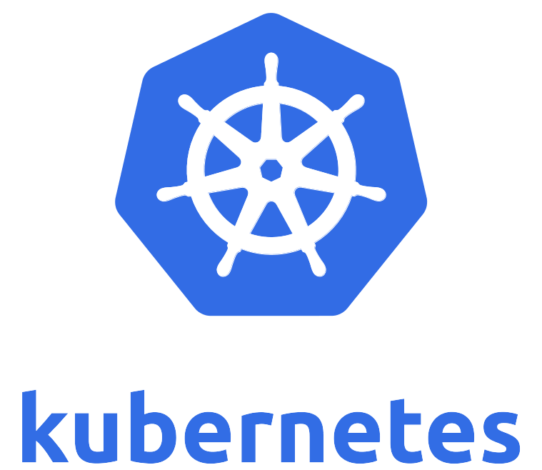
Since the launch of Kubernetes in 2014, IBM has been a contributor to its development, which was built by the open community. By pairing a Docker-powered engine with the simple management capabilities of Kubernetes, Bluemix developers can access a highly usable interface and dashboard to easily write code within a container and quickly deploy it to multiple apps. This clear view also enables developers to see where and when their code is running at any given point in time.
IBM released a beta of Kubernetes support in the IBM Bluemix Container Service on March 19, 2017. The IBM Bluemix Container Service, now combines Docker and Kubernetes to deliver powerful tools, an intuitive user experience, and built-in security and isolation to enable rapid delivery of applications all while leveraging Cloud Services including cognitive capabilities from Watson.
Using a single Kubernetes dashboard you can manage security compliance throughout your DevOps pipeline by automatically scanning both Docker images and live containers for known vulnerabilities and the presence of malware. Verify appropriate container settings and application configurations. Review risk ratings and match container service policies to those of your organization.
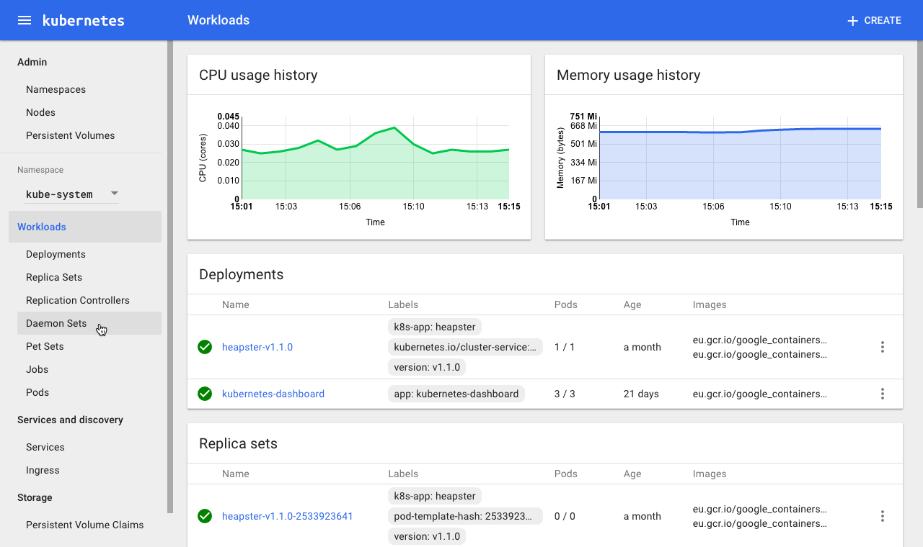

2.1.2 Kubernetes Architecture
The master is responsible for exposing the application program interface (API), scheduling the deployments and managing the overall cluster. Each node runs a container runtime, such as Docker or rkt, along with an agent that communicates with the master. The node also runs additional components for logging, monitoring, service discovery and optional add-ons. Nodes are the workhorses of a Kubernetes cluster. They expose compute, networking and storage resources to applications. Nodes can be virtual machines (VMs) running in a cloud or bare metal servers running within the data center.
A pod is a collection of one or more containers. The pod serves as Kubernetes’ core unit of management. Pods act as the logical boundary for containers sharing the same context and resources. The grouping mechanism of pods make up for the differences between containerization and virtualization by making it possible to run multiple dependent processes together. At runtime, pods can be scaled by creating replica sets, which ensure that the deployment always runs the desired number of pods.
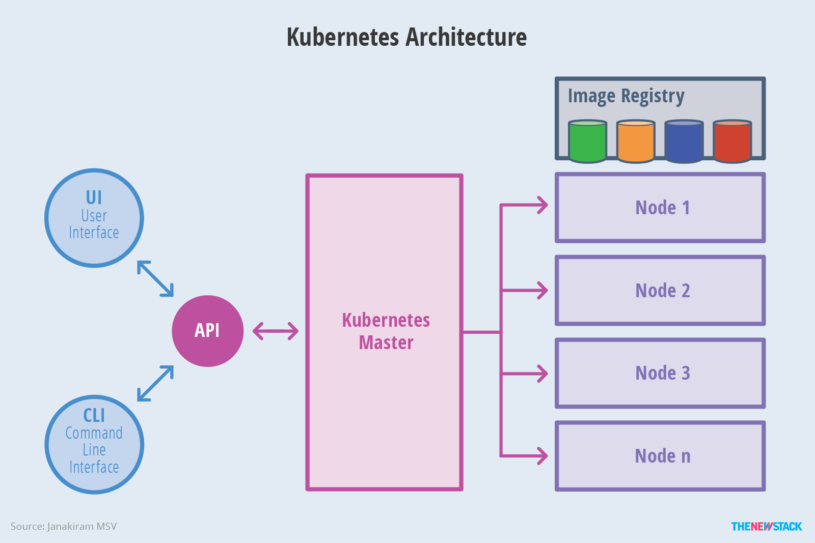
Replica sets deliver the required scale and availability by maintaining a pre-defined set of pods at all times. A single pod or a replica set can be exposed to the internal or external consumers via services. Services enable the discovery of pods by associating a set of pods to a specific criterion. Pods are associated to services through key-value pairs called labels and selectors. Any new pod with labels that match the selector will automatically be discovered by the service. This architecture provides a flexible, loosely-coupled mechanism for service discovery.

2.2 Google Service Control

Google Service Control is a Google Cloud Platform infrastructure service. It provides control plane functionality to managed services, such as logging, monitoring, and status checks. It is widely used by Google APIs and Google Cloud Endpoints.
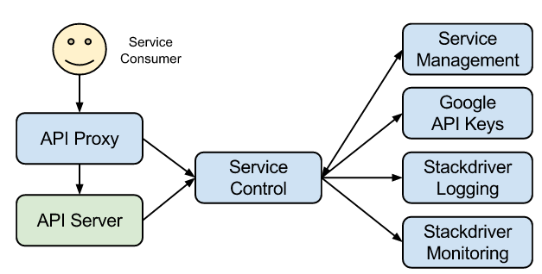

Google Service Control works with a set of managed services and their operations (activities), checks whether an operation is allowed to proceed, and reports completed operations. Behind the scenes, it leverages other Google Cloud services, such as Google Service Management, Stackdriver Logging, and Stackdriver Monitoring, while hiding their complexity from service producers. It uses caching, batching, aggregation, and retries to deliver higher performance and availability than individual backend systems it encapsulates.
Google Service Control uses the generic concept of an operation to represent the activities of a managed service, such as API calls and resource usage. Each operation is associated with a managed service and a specific service consumer, and has a set of properties that describe the operation, such as the API method name and resource usage amount.
The Service Control API provides the services.check method which determines whether an operation should be allowed to proceed for a managed service. By performing multiple checks within a single API call, it provides better performance, higher reliability, and reduced development cost to service producers compared to checking with multiple backend systems.
The Service Control API provides the services.report method which reports completed operations for a managed service to various backend systems, such as Stackdriver Logging and Stackdriver Monitoring. The reported data can be seen in the Google Cloud Platform Console, and retrieved with appropriate APIs, such as the Stackdriver Logging and Stackdriver Monitoring APIs.

2.3 Envoy

Envoy is an L7 proxy and communication bus designed for large modern service oriented architectures. Envoy is a self contained process that is designed to run alongside every application server. All of the Envoys form a transparent communication mesh in which each application sends and receives messages to and from localhost and is unaware of the network topology.
Modern C++11 code base: Envoy is written in C++11. Native code was chosen because we believe that an architectural component such as Envoy should get out of the way as much as possible. Modern application developers already deal with tail latencies that are difficult to reason about due to deployments in shared cloud environments and the use of very productive but not particularly well performing languages such as PHP, Python, Ruby, Scala, etc.
L3/L4 filter architecture: At its core, Envoy is an L3/L4 network proxy. A pluggable filter chain mechanism allows filters to be written to perform different TCP proxy tasks and inserted into the main server. Filters have already been written to support various tasks such as raw TCP proxy, HTTP proxy, and TLS client certificate authentication.
HTTP L7 filter architecture: HTTP is such a critical component of modern application architectures that Envoy supports an additional HTTP L7 filter layer. HTTP filters can be plugged into the HTTP connection management subsystem that perform different tasks such as buffering, rate limiting, routing/forwarding, etc.
Health checking: The recommended way of building an Envoy mesh is to treat service discovery as an eventually consistent process. Envoy includes a health checking subsystem which can optionally perform active health checking of upstream service clusters. Envoy then uses the union of service discovery and health checking information to determine healthy load balancing targets. Envoy also supports passive health checking via an outlier detection subsystem.
Advanced load balancing: Load balancing among different components in a distributed system is a complex problem. Because Envoy is a self contained proxy instead of a library, it is able to implement advanced load balancing techniques in a single place and have them be accessible to any application. Currently Envoy includes support for automatic retries, circuit breaking, global rate limiting via an external rate limiting service, request shadowing, and outlier detection. Future support is planned for request racing.

2.4 Amalgam8
IBM has made available an open source project named Amalgam8 which takes the tedium out of microservice management, enabling faster development, more control, and better resiliency of microservices without impacting existing implementation code. It provides advanced DevOps capabilities such as systematic resiliency testing, red/black deployment, and canary testing necessary for rapid experimentations and insight.[17]

Illustration 1: Amalgam8 Logo
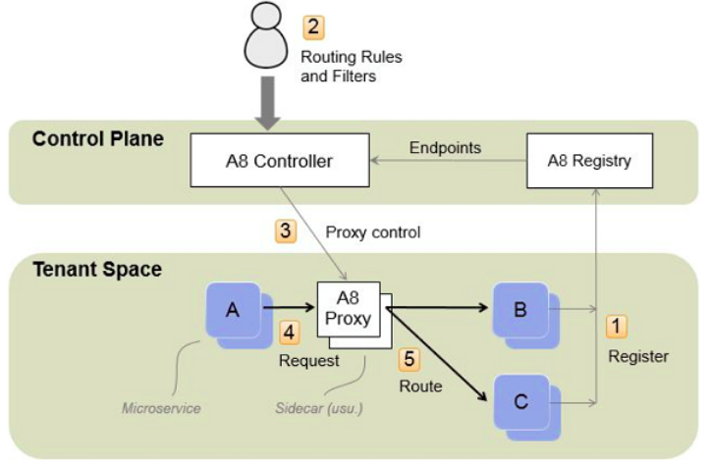
Illustration 2: Amalgam8 Architecture

At the heart of Amalgam8 are two multi-tenanted services:
- Registry – A high-performance service registry that provides a centralized view of all the microservices in an application, regardless of where they are actually running.
- Controller – A tool that monitors the Registry and provides a REST API for registering routing and other microservice control-rules, which it uses to generate and send control information to proxy servers running within the application
Applications run as tenants of these two servers. They register their services in the Registry and use the Controller to manage proxies, usually running as sidecars of the microservices.
- Microservice instances are registered in the A8 Registry.
- An Administrator specifies routing rules and filters (such as version rules and test delays) to control traffic flow between microservices.
- An A8 Controller monitors the A8 Registry and administrator input, and then generates control information that is sent to the A8 Proxies.
- Requests to microservices are made through an A8 Proxy (usually a client-side sidecar of another microservice).
- The A8 Proxy forwards requests to an appropriate microservice, depending on the request path and headers and the configuration specified by the controller.

3 Istio

3.1 About Istio
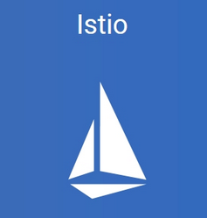
On May 24, 2017, IBM and Google announced the launch of Istio, an open technology that provides a way for developers to seamlessly connect, manage and secure networks of different microservices—regardless of platform, source or vendor.
Istio is the result of a joint collaboration between IBM, Google and Lyft as a means to support traffic flow management, access policy enforcement and the telemetry data aggregation between microservices. It does all this without requiring developers to make changes to application code by building on earlier work from IBM, Google and Lyft. Istio currently runs on Kubernetes platforms, such as the IBM Bluemix Container Service. Its design, however, is not platform specific.
As microservices scale dynamically, problems such as service discovery, load balancing and failure recovery become increasingly important to solve uniformly. The individual development teams manage and make changes to their microservices independently, making it difficult to keep all of the pieces working together as a single unified application.
Before combining forces, IBM, Google, and Lyft had been addressing separate, but complementary, pieces of the overall problem.
- IBM’s Amalgam8 project, a unified service mesh that was created and open sourced last year, provided a traffic routing fabric with a programmable control plane to help its internal and enterprise customers with A/B testing, canary releases, and to systematically test the resilience of their services against failures.
- Google’s Service Control provided a service mesh with a control plane that focused on enforcing policies such as ACLs, rate limits and authentication, in addition to gathering telemetry data from various services and proxies.
- Lyft developed the Envoy proxy to aid their microservices journey, which brought them from a monolithic app to a production system spanning 10,000+ VMs handling 100+ microservices. IBM and Google were impressed by Envoy’s capabilities, performance, and the willingness of Envoy’s developers to work with the community.

IBM, Google and Lyft realised it would be beneficial to combine their efforts by creating a first-class abstraction for routing and policy management in Envoy, and expose management plane APIs to control Envoys in a manner that can be easily integrated with CI/CD pipelines. In addition to developing the Istio control plane, IBM also contributed several features to Envoy such as traffic splitting across service versions, distributed request tracing with Zipkin and fault injection. Google hardened Envoy on several aspects related to security, performance, and scalability.

3.2 Architecture
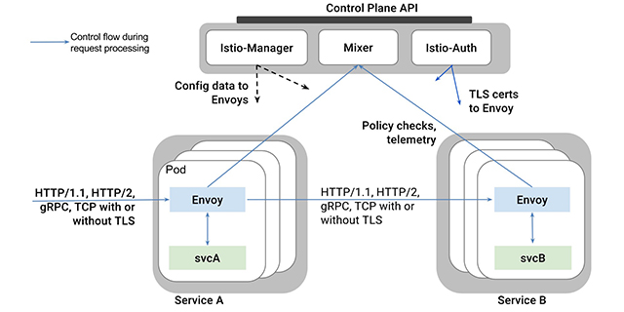

Istio converts disparate microservices into an integrated service mesh by introducing programmable routing and a shared management layer. By injecting Envoy proxy servers into the network path between services, Istio provides sophisticated traffic management controls such as load-balancing and fine-grained routing. This routing mesh also enables the extraction of a wealth of metrics about traffic behavior, which can be used to enforce policy decisions such as fine-grained access control and rate limits that operators can configure. Those same metrics are also sent to monitoring systems. This way, it offers improved visibility into the data flowing in and out of apps.
It is possible to enforce authentication and authorization between any pair of communicating services. Today, the communication is automatically secured via mutual TLS authentication with automatic certificate management.

- Automatic zone-aware load balancing and failover for HTTP/1.1, HTTP/2, gRPC, and TCP traffic. Fine-grained control of traffic behavior with rich routing rules, fault tolerance, and fault injection.
- A pluggable policy layer and configuration API supporting access controls, rate limits and quotas. Automatic metrics, logs and traces for all traffic within a cluster, including cluster ingress and egress.
- Secure service-to-service authentication with strong identity assertions between services in a cluster.

3.3 Istio-Manager and Services
Istio-Manager is responsible for the lifecycle of Envoy instances deployed across the Istio service mesh.
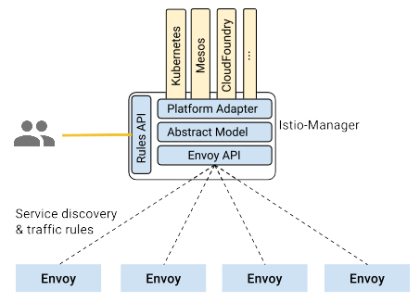
As illustrated in figure x, Istio-Manager maintains a canonical representation of services in the mesh that is independent of the underlying platform. Platform-specific adapters in the manager are responsible for populating this canonical model appropriately. For example, the Kubernetes adapter in the Istio-Manager implements the necessary controllers to watch the Kubernetes API server for changes to the pod registration information, ingress resources, and third party resources that store traffic management rules. This data is translated into the canonical representation. Envoy-specific configuration is generated based on the canonical representation.
Istio-Manager exposes APIs for service discovery, dynamic updates to load balancing pools and routing tables. These APIs decouple Envoy from platform-specific nuances, simplifying the design and increasing portability across platforms.
Operators can specify high-level traffic management rules through the Istio-Manager’s Rules API. These rules are translated into low-level configurations and distributed to Envoy instances via the discovery API.
As described in Istio-Manager, the canonical representation of services in a particular mesh is maintained by Istio-Manager. The Istio model of a service is independent of how it is represented in the underlying platform (Kubernetes, Mesos, Cloud Foundry, etc.). Platform-specific adapters are responsible for populating the internal model representation with various fields from the metadata found in the platform.
Istio introduces the concept of a service version, which is a finer-grained way to subdivide service instances by versions (v1, v2) or environment (staging, prod). These variants are not necessarily different API versions: they could be iterative changes to the same service, deployed in different environments (prod, staging, dev, etc.). Common scenarios where this is used include A/B testing or canary rollouts. Istio’s traffic routing rules can refer to service versions to provide additional control over traffic between services.

3.4 Service Versioning
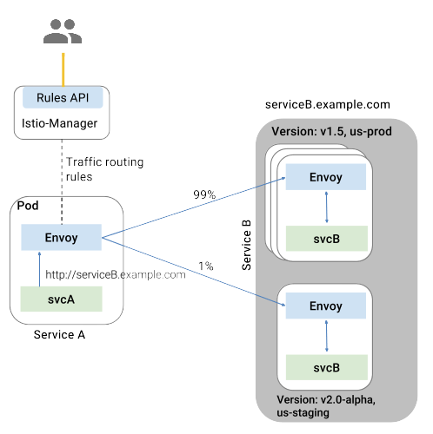
As illustrated in figure x, clients of a service have no knowledge of different versions of the service. They can continue to access the services using the hostname/IP address of the service. The Envoy sidecar/proxy intercepts and forwards all requests/responses between the client and the service.
Envoy determines its actual choice of service version dynamically based on the routing rules specified by the operator using Istio-Manager. This model enables the application code to decouple itself from the evolution of its dependent services, while providing other benefits as well (see Mixer). Routing rules allow Envoy to select a version based on criterion such as headers, tags associated with source/destination, and/or by weights assigned to each version.
Istio also provides load balancing for traffic to multiple instances of the same service version. You can find out more about this in Discovery and Load-Balancing.
Istio does not provide a DNS. Applications can try to resolve the FQDN using the DNS service present in the underlying platform (kube-dns, mesos-dns, etc.).

3.5 Ingress and Egress Envoys
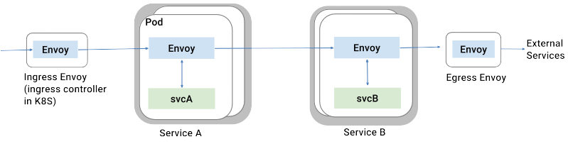
Istio assumes that all traffic entering and leaving the service mesh transits through Envoy proxies. By deploying the Envoy proxy in front of services, operators can conduct A/B testing, deploy canary services, etc. for user-facing services. Similarly, by routing traffic to external web services (for instance, accessing the Maps API, or a video service API) via Envoy, operators can add failure recovery features such as circuit breakers, impose rate limits via Mixer, and provide authentication using Istio-Auth.

3.6 Discovery & Load Balancing
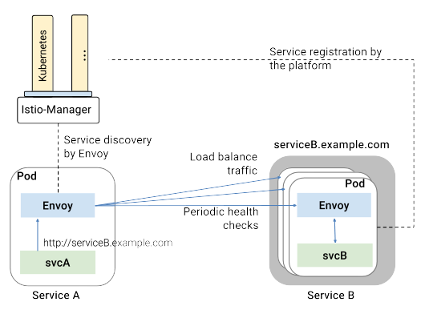
As illustrated in the figure above, services in the mesh access each other using their DNS names. All HTTP traffic bound to a service is automatically re-routed through Envoy. Envoy distributes the traffic across instances in the load balancing pool. While Envoy supports several sophisticated load balancing algorithms, Istio currently allows three load balancing modes: round robin, random, and weighted least request.
In addition to load balancing, Envoy periodically checks the health of each instance in the pool. Envoy follows a circuit breaker style pattern to classify instances as unhealthy or healthy based on their failure rates for the health check API call. In other words, when the number of health check failures for a given instance exceeds a pre-specified threshold, it will be ejected from the load balancing pool. Similarly, when the number of health checks that pass exceed a pre-specified threshold, the instance will be added back into the load balancing pool. You can find out more about Envoy’s failure-handling features in Handling Failures.
Services can actively shed load by responding with a HTTP 503 to a health check. In such an event, the service instance will be immediately removed from the caller’s load balancing pool.

3.7 Handling Failures
Envoy provides the following recovery features:
- Timeouts
- Bounded retries with timeout budgets and variable jitter between retries
- Limits on number of concurrent connections and requests to upstream services
- Active (periodic) health checks on each member of the load balancing pool
- Fine-grained circuit breakers (passive health checks) – applied per instance in the load balancing pool
The jitter between retries minimizes the impact of retries on an overloaded upstream service, while timeout budgets ensure that the calling service gets a response (success/failure) within a predictable timeframe.
A combination of active and passive health checks minimizes the chances of accessing an unhealthy instance in the load balancing pool. When combined with platform-level health checks, applications can ensure that unhealthy pods/containers/VMs can be quickly weeded out of the service mesh, minimizing the request failures and impact on latency.

3.8 Rules Configuration
Istio provides a simple Domain-specific language (DSL) to control how API calls and layer-4 traffic flow across various services in the application deployment. The DSL allows the operator to configure service-level properties such as circuit breakers, timeouts, retries, as well as set up common continuous deployment tasks such as canary rollouts, and A/B testing.

3.8.1 Qualify rules by destination
Every rule corresponds to some destination service identified by a destination field in the rule. For example, all rules that apply to calls to the “reviews” service will include the following field.
destination: reviews.default.svc.cluster.local
The destination value SHOULD be a fully qualified domain name (FQDN). It is used by Istio-Manager for matching rules to services.

3.8.2 Split traffic between service versions
Each route rule identifies one or more weighted backends to call when the rule is activated. Each backend corresponds to a specific version of the destination service, where versions can be expressed using tags.
If there are multiple registered instances with the specified tag(s), they will be routed to based on the load balancing policy configured for the service, or round-robin by default.

3.8.3 Destination policies
Destination policies describe various routing related policies associated with a particular service version, such as the load balancing algorithm, the configuration of circuit breakers, health checks, etc. Unlike route rules, destination policies cannot be qualified based on attributes of a request such as the calling service or HTTP request headers.
However, the policies can be restricted to apply to requests that are routed to backends with specific tags. For example, the following load balancing policy will only apply to requests targeting the “v1” version of the “reviews” microservice.
destination: reviews.default.svc.cluster.local
tags:
version: v1
loadBalancing: RANDOM

3.9 Auth
Istio Auth’s aim is to enhance the security of microservices and their communication without requiring service code changes. It is responsible for:
- Providing each service with a strong identity that represents its role to enable interoperability across clusters and clouds
- Securing service to service communication
- Providing a key management system to automate key and certificate generation, distribution, rotation, and revocation

3.9.1 Architecture
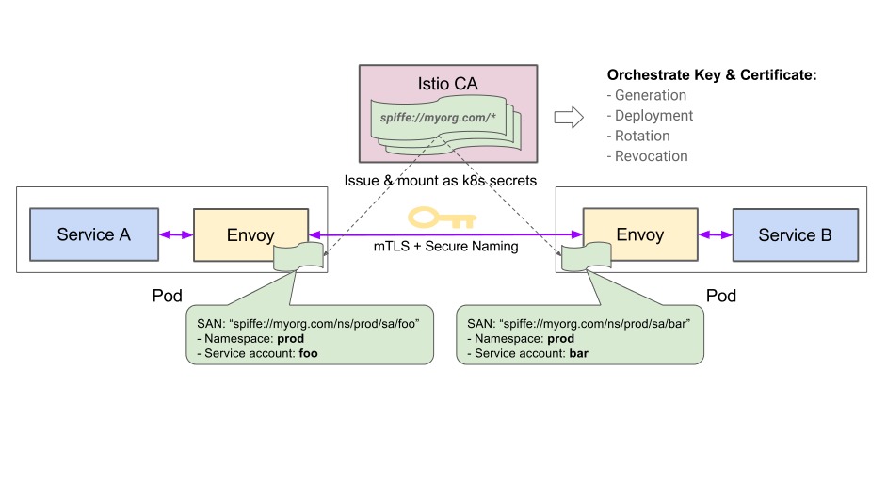
The figure x shows the Istio Auth architecture, which includes three components: identity, key management, and communication security. It describes how Istio Auth is used to secure service-to-service communication between service A, running as service account “foo”, and service B, running as service account “bar”.

3.9.2 Identity
When running on Kubernetes, Istio Auth uses Kubernetes service accounts to identify who runs the service because of the following reasons:
- A service account is the identity (or role) a workload runs as, which represents that workload’s privileges. For systems requiring strong security, the amount of privilege for a workload should not be identified by a random string (i.e., service name, label, etc), or by the binary that is deployed.
- Service accounts enable strong security policies by offering the flexibility to identify a machine, a user, a workload, or a group of workloads (different workloads can run as the same service account).
- The service account a workload runs as won’t change during the lifetime of the workload.
- Service account uniqueness can be ensured with domain name constraint

3.9.3 Communication security
Service-to-service communication is tunneled through the client side Envoy and the server side Envoy. End-to-end communication is secured by:
- Local TCP connections between the service and Envoy
- Mutual TLS connections between proxies
- Secure Naming: during the handshake process, the client side Envoy checks that the service account provided by the server side certificate is allowed to run the target service

3.9.4 Key management
Istio Auth provides a per-cluster CA (Certificate Authority) to automate key and certificate management. It performs four key operations:
- Generate a SPIFFE key and certificate pair for each service account
- Distribute a key and certificate pair to each pod according to the service account
- Rotate keys and certificates periodically
- Revoke a specific key and certificate pair when necessary

3.9.5 Workflow
Istio Auth workflow consists of two phases, deployment and runtime. This section covers both of them.

3.9.5.1 Deployment phase
- Istio CA watches Kubernetes API Server, creates a SPIFFE key and certificate pair for each of the existing and new service accounts, and sends them to API Server.
- When a pod is created, API Server mounts the key and certificate pair according to the service account using Kubernetes secrets.
- Istio Manager generates the config with proper key and certificate and secure naming information, which defines what service account(s) can run a certain service, and passes it to Envoy.

3.9.5.2 Runtime phase
- The outbound traffic from a client service is rerouted to its local Envoy.
- The client side Envoy starts a mutual TLS handshake with the server side Envoy. During the handshake, it also does a secure naming check to verify that the service account presented in the server certificate can run the server service.
- The traffic is forwarded to the server side Envoy after mTLS connection is established, which is then forwarded to the server service through local TCP connections.

3.10 Policies and Control

3.10.1 Attributes
Istio uses attributes to control the runtime behavior of services running in the service mesh. Attributes are named and typed pieces of metadata describing ingress and egress traffic and the environment this traffic occurs in. An Istio attribute carries a specific piece of information such as the error code of an API request, the latency of an API request, or the original IP address of a TCP connection.

3.10.2 Mixer
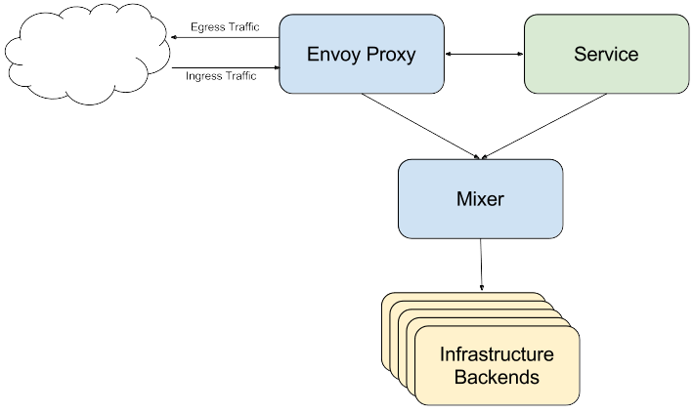
Mixer provides a generic intermediation layer between application code and infrastructure backends. Its design moves policy decisions out of the app layer and into configuration instead, under operator control. Instead of having application code integrate with specific backends, the app code instead does a fairly simple integration with Mixer, and Mixer takes responsibility for interfacing with the backend systems.
Mixer provides three core features:
- Precondition Checking. Enables callers to verify a number of preconditions before responding to an incoming request from a service consumer. Preconditions can include whether the service consumer is properly authenticated, is on the service’s whitelist, passes ACL checks, and more.
- Quota Management. Enables services to allocate and free quota on a number of dimensions, Quotas are used as a relatively simple resource management tool to provide some fairness between service consumers when contending for limited resources. Rate limits are examples of quotas.
- Telemetry Reporting. Enables services to report logging and monitoring. In the future, it will also enable tracing and billing streams intended for both the service operator as well as for service consumers.

These mechanisms are applied based on a set of attributes that are materialized for every request into Mixer. Within Istio, Envoy depends heavily on Mixer. Services running within the mesh can also use Mixer to report telemetry or manage quotas

3.10.3 Request phases
When a request comes in to Mixer, it goes through a number of distinct handling phases:
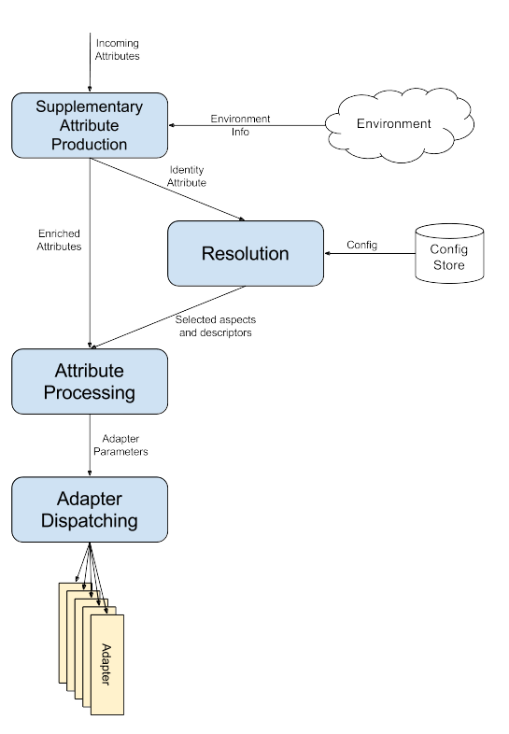
- Supplementary Attribute Production.
The first thing that happens in Mixer is to run a globally configured set of adapters that are responsible for introducing new attributes. These attributes are combined with the attributes from the request to form the total set of attributes for the operation.
- Resolution. The second phase is to evaluate the set of attributes to determine the effective configuration to apply for the request. See here for information on how resolution works. The effective configuration determines the set of aspects and descriptors available to handle the request in the subsequent phases.
- Attribute Processing. The third phase takes the total set of attributes and produces a set of adapter parameters. Attribute processing is initially configured through a simple declarative form as described here.
- Adapter Dispatching. The Resolution phase establishes the set of available aspects and the Attribute Processing phase creates a set of adapter parameters. The Adapter Dispatching phase invokes the adapters associated with each aspect and passes them those parameters.

